About Me
Passionate and creative UI/UX Designer with a strong understanding of user-centered design, wireframing, prototyping, and responsive interface design. Proficient in Figma, with working knowledge of HTML, CSS, and basic Java, allowing me to bridge the gap between design and development. A quick learner, detail-oriented, and eager to contribute to real-world projects while continuously improving my skills.

Education

UNIVERSITY OF AGRICULTURE FAISALABAD | 2022 - 2026
Bachelor of Information technology (2.8 CGPA)
IQRA COLLEGE OF SCIENCE AND COMMERCE  Intermediate (FA.IT) 587 Marks | 2020 - 2022
GOVERNMENT BOYS HIGH SCHOOL  Matriculation (Science) 612 marks | 2018 - 2020
Experience
MCB BANK LIMITED April 2026 - May 2026

INTERN
Observed transaction workflows and assessed how core banking software ensures secure and efficient services.
Gained practical insights that bridged academic knowledge with real-world banking practices.

Tech hub Innovation Center Sep 2025 - Dec 2025

UI/UX DESIGN INTERN
Designed responsive website and mobile app interfaces in Figma.
Created wireframes, mockups, and interactive prototypes. Improved user experience through usability testing and design optimization.

Achievement

NAVTTC

2026

Completed training in UI/UX design and user-centered design.

TECH HUB

2025

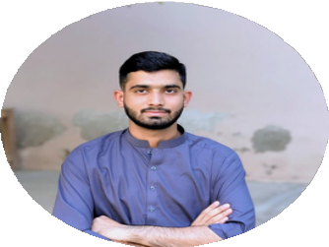Completed a UI/UX Design internship focused on wireframing and prototyping.
MUHAMMAD TAYYAB SAEED
Contact
+92 344 4317343

tayyabsaeed49494@gmail.com

Chak No. 343 GB Jurahan Toba Tek Singh
https://www.linkedin.com/in/t ayaab-saeed-6761ab321
Skills

Management Skills Creativity
Digital Marketing Negotiation Critical Thinking
Leadership
Language
English Urdu

Creative Work
Final Year Project
AI-Based EEG Signal Classification for Sleep Disorder Detection
Performed EEG data preprocessing and feature extraction (RMS). Technologies: Python, TensorFlow/PyTorch, Scikit-learn, NumPy, Pandas, Dash/Flask, PostgreSQL

